|  |  |  |
| --- | --- | --- |
| Q1 | 1. What are the three main goals of an operating system  * Execute user programs and make solving user problems easier * Make the computer system convenient to use * Use the computer hardware in an efficient manner  1. Draw the four components of a computer system 2. Which of the following instructions should be privileged?  * Set value of timer. * Clear memory. * Turn off interrupts. * Modify entries in device-status table. * Access I/O device. |  |
| Q2 | |  |  |  |  | | --- | --- | --- | --- | |  |  |  |  |  1. What are the main advantages of multiprocessor systems?  * Increased throughput * Economy of scale * Increased reliability  1. What is the difference between Asymmetric and Symmetric Multiprocessing? Then draw the Symmetric multiprocessing architecture.  * Asymmetric Multiprocessing – each processor is assigned a specie task. * Symmetric Multiprocessing – each processor performs all tasks |  |

Q1: B)

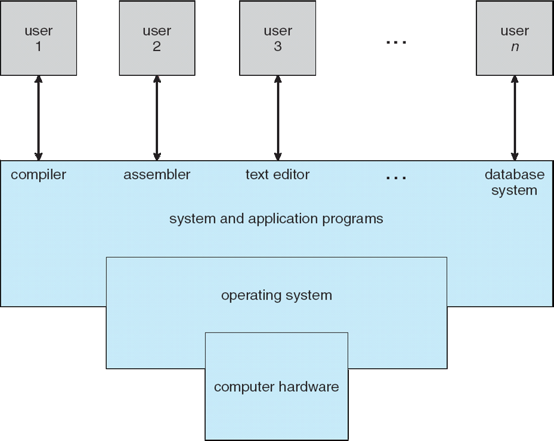

Q2: B)

